HOME PAGE:

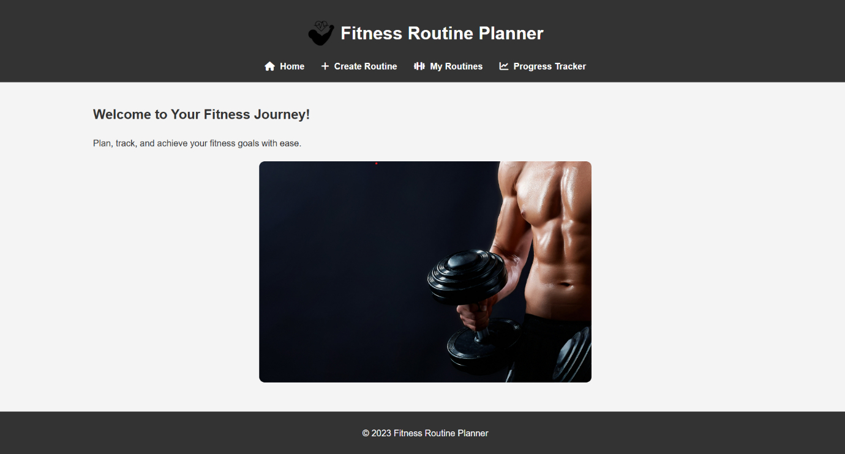

**NAVIGATING THROUGH PAGES**

CREATING A ROUTINE:

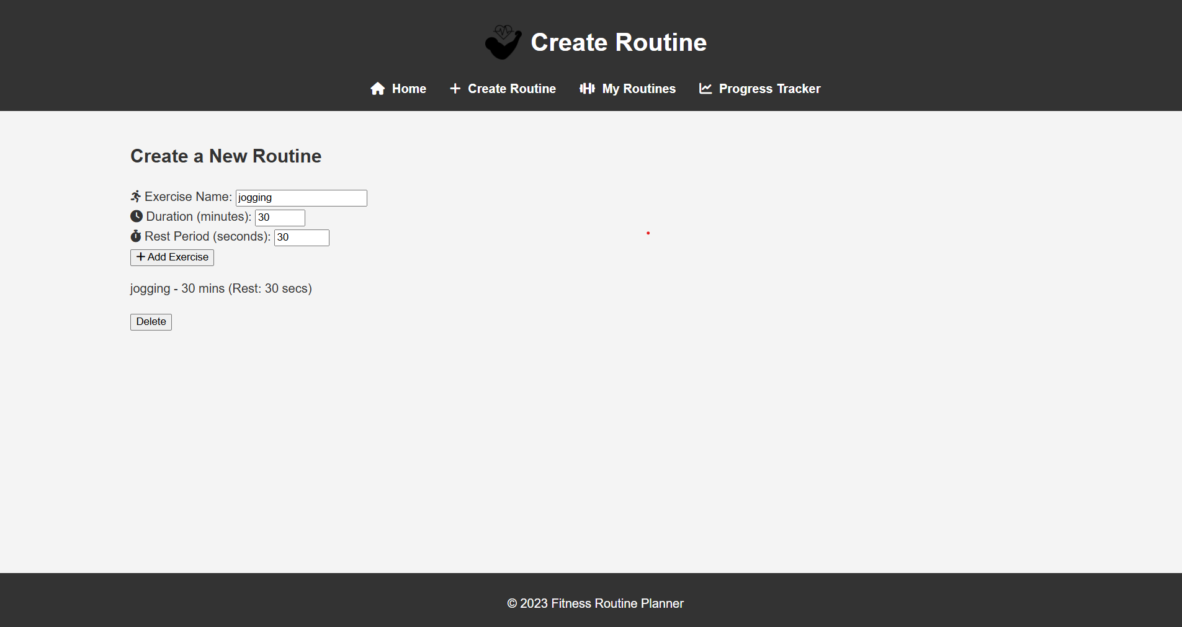

VIEWING ROUTINES ADDED:

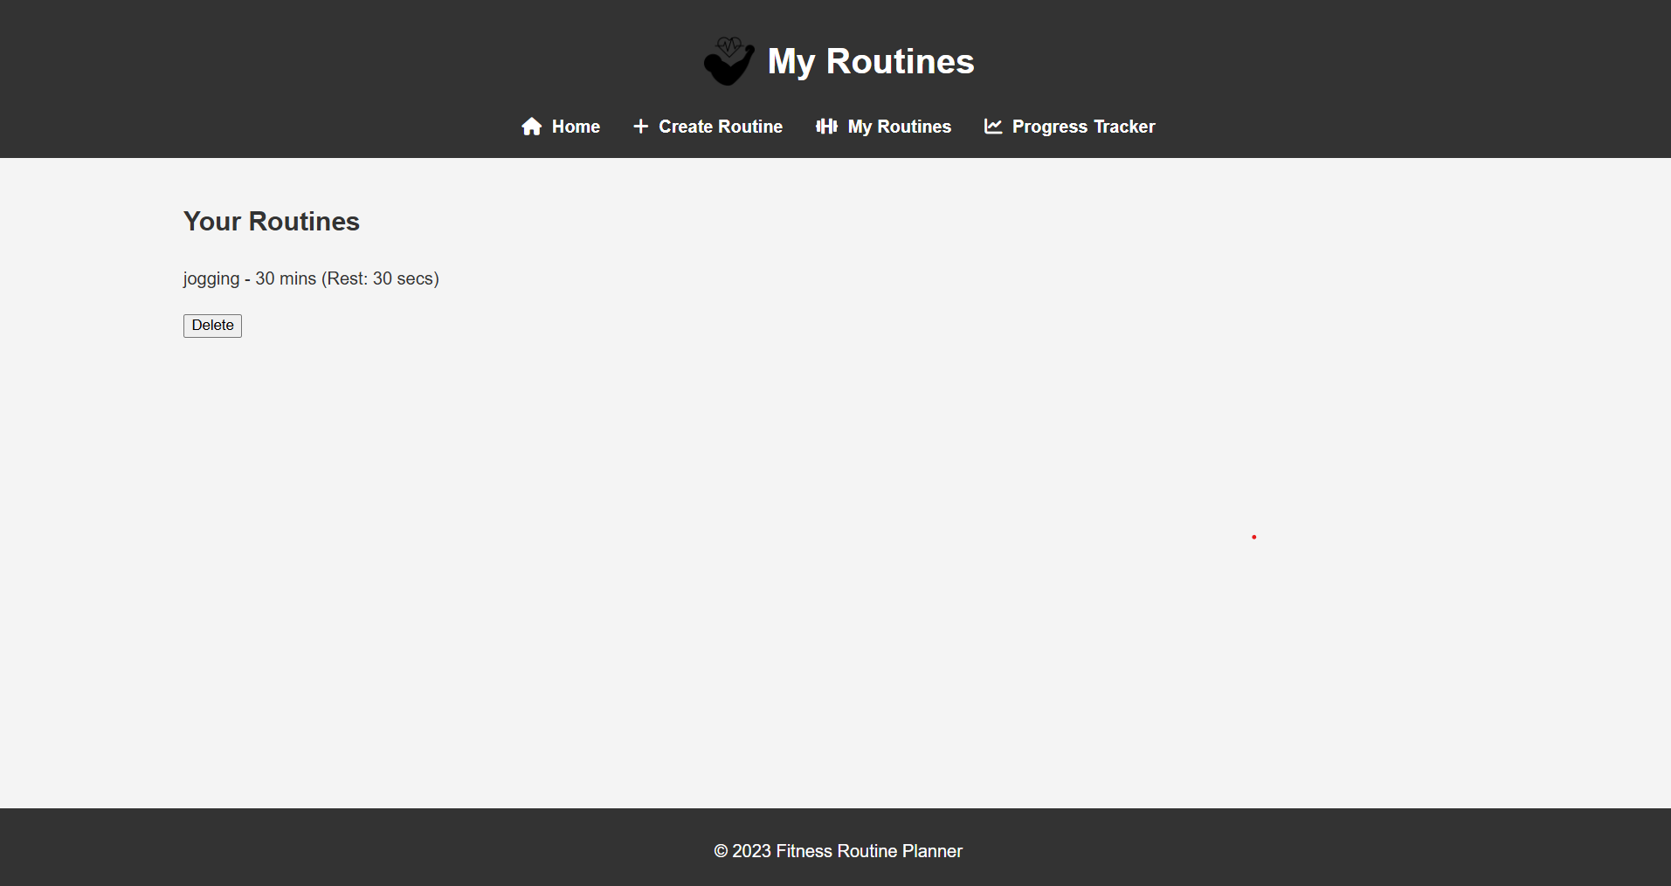

DELETING ROUTINES:

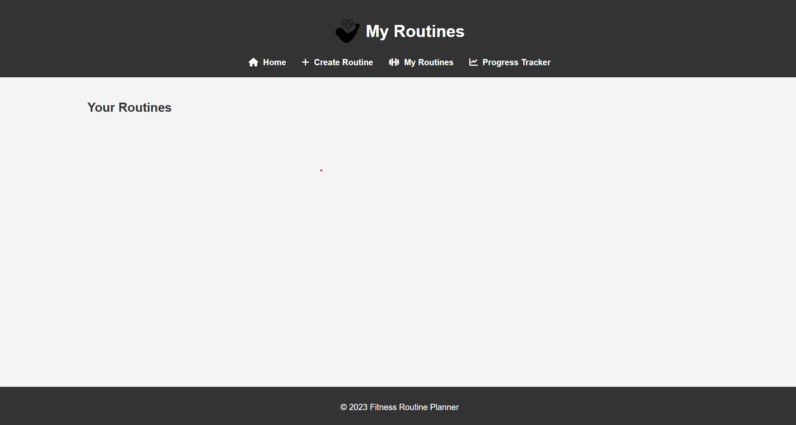

PROGRESS TRACKING:

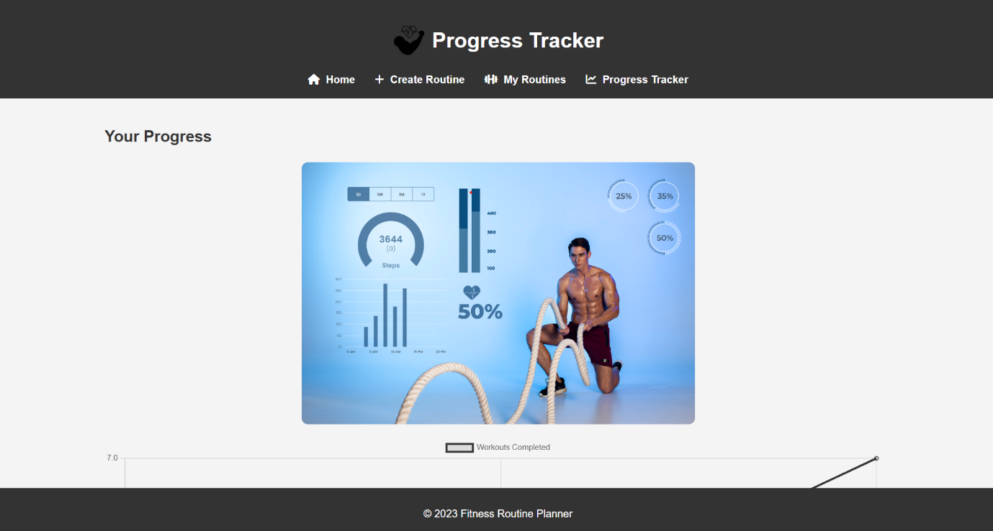

SIMPLE DAY_BY_GRAPH:

